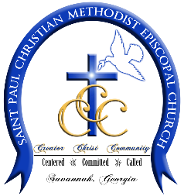
St. Paul CME Church
1601 Barnard Street
Savannah, GA 31401
(912) 233-2849 Phone (912) 233-2849 Fax
Rev. Dr. Da’Henri R. Thurmond, Sr. - Pastor

WEDDING FORM

Bride: Click or tap here to enter text. Phone: XXX-XXX-XXXX

Groom: Click or tap here to enter text. Phone: XXX-XXX-XXXX

Bride’s Email: Click or tap here to enter text.

Groom’s Email: Click or tap here to enter text.

Wedding Date: Click or tap to enter a date. Times: Click or tap here to enter text.
Location: Click or tap here to enter text.
Officiant: Click or tap here to enter text.
Number in Wedding Party: Click or tap here to enter text.

Anticipated Guest : Click or tap here to enter text.

Counseling Session #1: Click or tap here to enter text.

Counseling Session #2: Click or tap here to enter text.

Counseling Session #3: Click or tap here to enter text.

