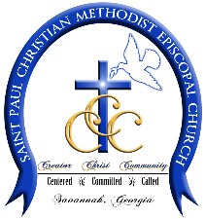
ST. PAUL CME CHURCH
TRANSPORTATION REQUEST FORM
Name of Individual / Ministry: Click or tap here to enter text.
Date of Request: Click or tap to enter a date.
Date of Trip: Click or tap to enter a date.
Departure Time: Click or tap here to enter text.
Destination: Click or tap here to enter text.
Return Time: Click or tap here to enter text.
Name of Group Leader: Click or tap here to enter text.
Group Leader’s Cell Number: XXX-XXX-XXXX
Group Leader’s Email Address: Click or tap here to enter text.
Number of Participants: Click or tap here to enter text.
Purpose of Trip and Trip Itinerary: Attach additional sheet if necessary

RETURN COMPLETED FORM TO TRUSTEE MINISTRY MAILBOX
FOR OFFICE USE ONLY
Request Approved: ☐ Request Denied: ☐
Reason: Click or tap here to enter text.

Signed: ______________________________________________ Date: Click or tap to enter a date.
TERMS & CONDITIONS
This request is based upon the information provided above, If the request is approved, a driver will be secured by the Trustee Ministry. Each ministry/individual making request is responsible for adhering to the following:
- Driver will be paid by said ministry/individual.
- Ministry/Individual will pay for gas.
- NO FOOD OR BEVERAGES ARE ALLOWED ON THE BUS
- Ministry/Individual must ensure that bus is cleaned upon return or cleaning fee will be assessed.
☐ I agree to the term and conditions above. ☐ I disagree to the terms and conditions above.
Signed ____________________________________________ Date: Click or tap to enter a date.

