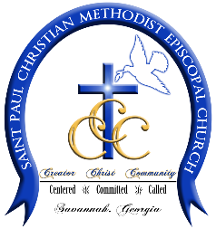
St. Paul CME Church
1601 Barnard Street
Savannah, GA 31401
(912) 233-2849 Phone (912) 233-2849 Fax
Rev. Dr. Da’Henri R. Thurmond, Sr. - Pastor

FACILITY USE REQUEST FORM
(FOR Non-Membership Events Only)
All requests must be submitted at least 30 days prior to the planned events(s).
All requests for use of facilities must be submitted to the Chairperson of the Trustee Board through the Church Office on the form in order to be processed.
PLEASE NOTE: Members who desire to use St. Paul Facilities for “non-membership events” must use this request form.
Today’s Date: Click or tap to enter a date.
Organization or Person Name: Click or tap here to enter text.
Type of Meeting or Event: Click or tap here to enter text.

Date(s) Requested Times(s) Requested:
Click or tap here to enter text. Click or tap here to enter text.
Click or tap here to enter text. Click or tap here to enter text.
Click or tap here to enter text. Click or tap here to enter text.
Requested Facility:
☐ Sanctuary ☐ Social Hall & Kitchen ☐ Social Hall Only
Anticipated number of persons attending meeting/event: Click or tap here to enter text.
Contact Person: Enter First, M.I. and Last Name
Address: Click or tap here to enter text.
Work Telephone Number: Click or tap here to enter text. Home Telephone Number: Click or tap here to enter text.
Email: Click or tap here to enter text.
To be completed by St. Paul CME Church Board of Trustees
☐ Request Approved Date: Click or tap to enter a date.
☐ Request Not Approved Date: Click or tap to enter a date.
Reason Request Not Approved: Click or tap here to enter text.
Approved or Not Approved use of facility confirmed with requested party:
By: Click or tap here to enter text. Date: Click or tap to enter a date.

